Peter Victoratos

CSC 411

Spurlock

Lab 12 Videos Writeup

Original

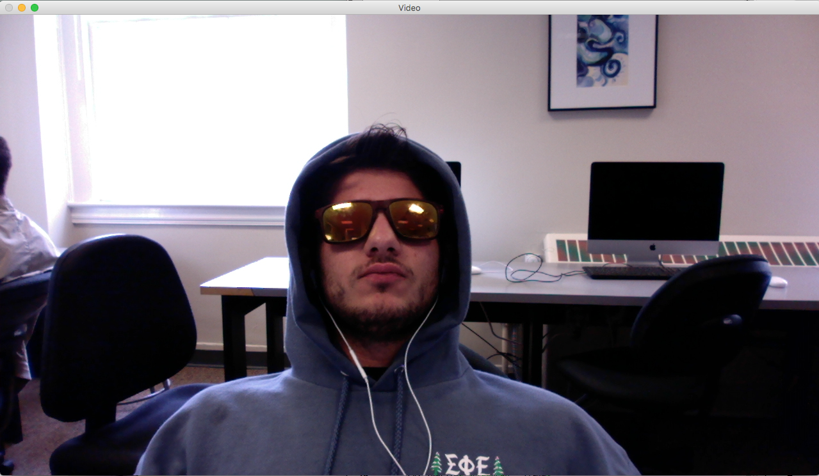

Sketch

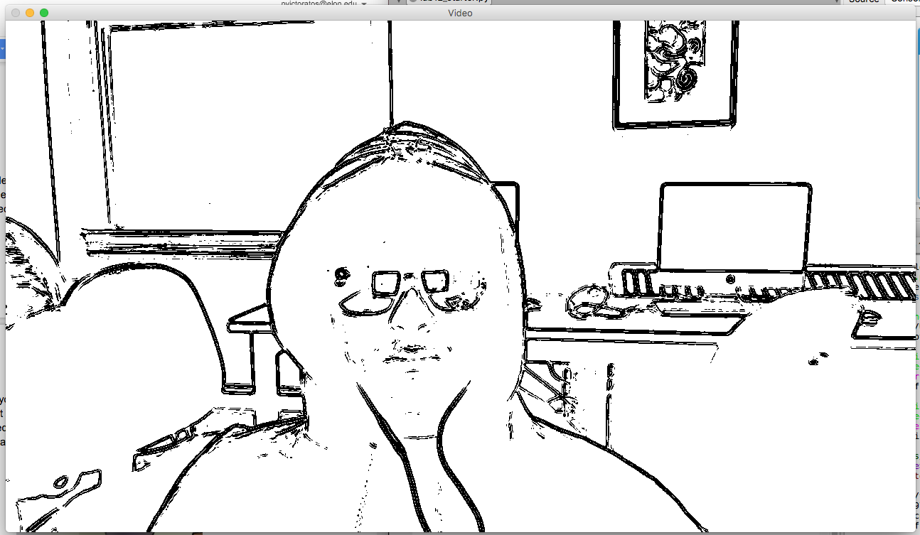

Paint

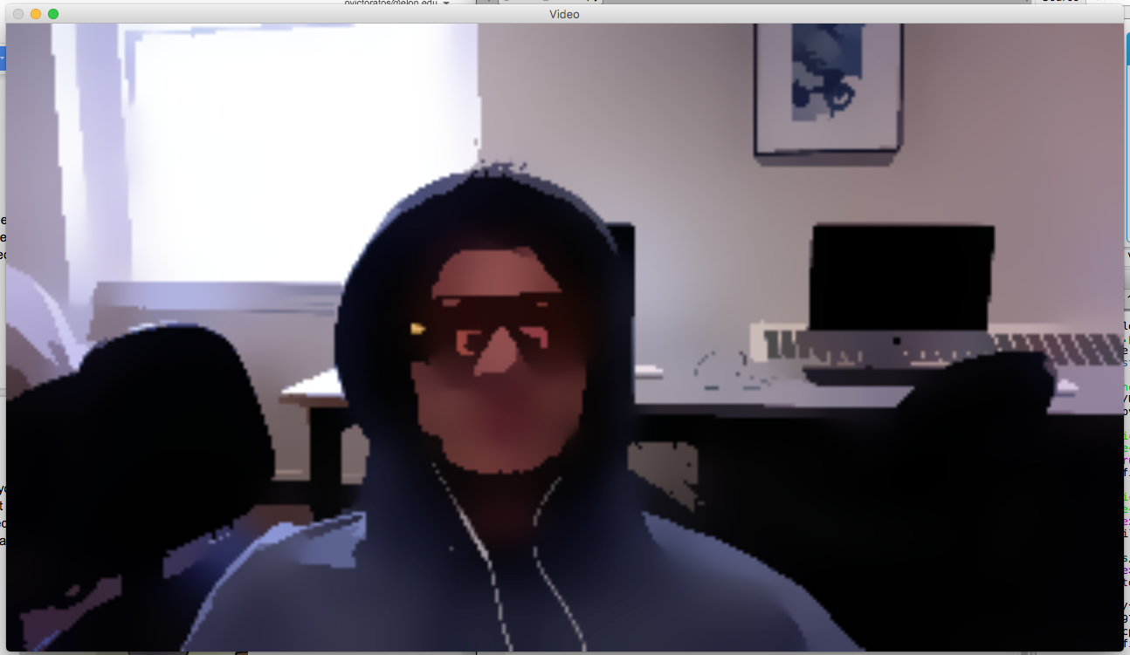

Cartoon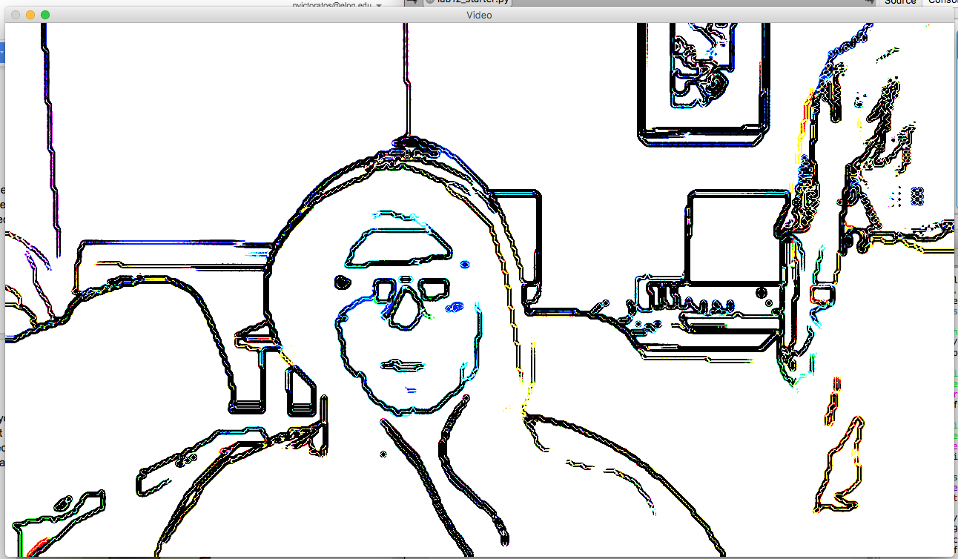

I removed the black and white filtering from the sketch model. However it took the color from the foreground and put it on the sketches and the rest of the image white. Maybe if I made the normalization not inverse it might have worked better.